# ALMA EDM Documents Migration

## Instructions (v.0.1)

1. Download the spreadsheet file EDMForums.xlsx from [NRAO AstroCloud](https://astrocloud.nrao.edu/s/jDD4EXFpof4STRR)

The file lists all the top-level structure of the ALMA EDM website.

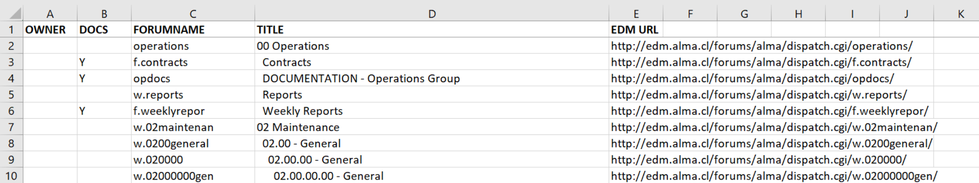

Columns:

* OWNER is empty and instructions for filling that are given below.
* DOCS is ‘Y’ if there is a document share or discussion forum connected to the row. Rows where DOCS is blank are pure directory or website structure; they have no content of their own.
* FORUMNAME you can ignore for now.
* TITLE shows the nested (hierarchical) structure.
* The EDM URL should take you to the corresponding page on ALMA EDM. I have only tested a handful of these, so no guarantees.

1. Enter your name or your group’s name under OWNER next to any document share or structure you want to take ownership of. If you select a row having nested structure, all that structure will be included in your selection.

In this example, FRONTEND has taken ownership of all the items up through and including ‘Test Forum’:

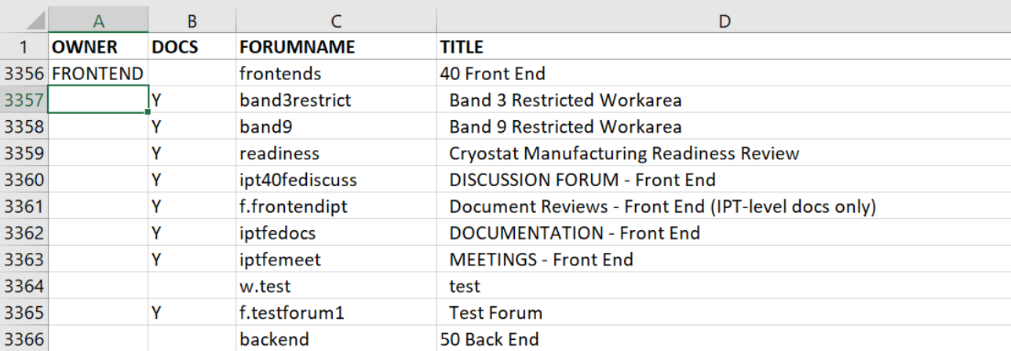

In this example, FRONTEND was more selective:

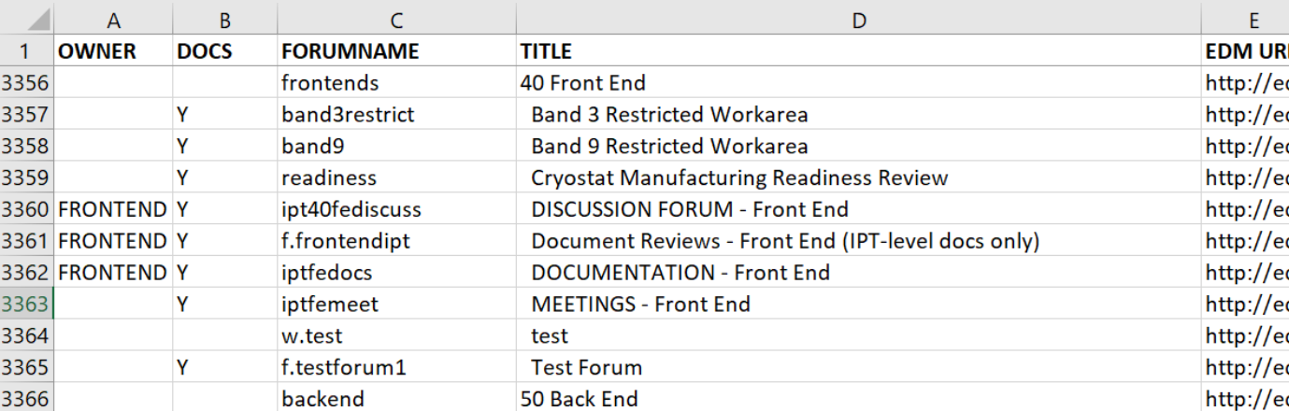

1. Rename the Excel spreadsheet file to include one or more of the OWNER names you used.

For example: FRONTEND-EDMForums.xlsx

1. Upload the file to the [Uploads folder](https://astrocloud.nrao.edu/s/eij3MX6GMQPbe3x) on NRAO AstroCloud.

Notify Morgan McLeod <mailto:mmcleod@nrao.edu> of your upload so I can associate the file with your email address.

1. After the spreadsheet is uploaed to AstroCloud, I will create one *Documents* spreadsheet corresponding to each submission.

It will have one tab per selected forum.

I will also create a new upload/download folder for each submission and

Details are subject to change, but the general instructions will hold.

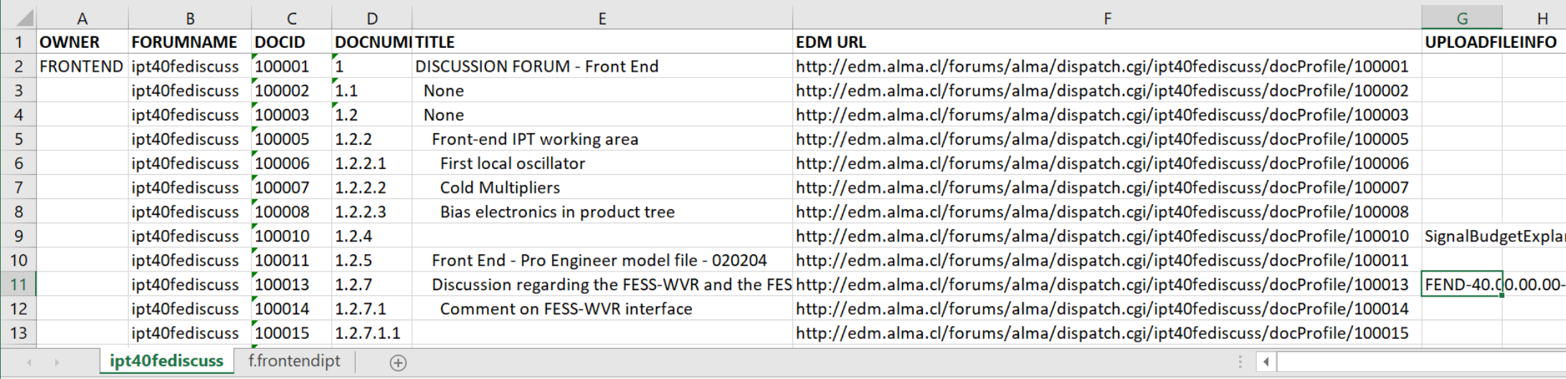

Columns in the created Documents spreadsheet:

* OWNER is empty except for the top-level item which is marked with the OWNER name you used previously.
* DOCID is the unique item identifier within the document share.
* DOCNUM and TITLE show the structure of folders and documents.
* The EDM URL should take you to the corresponding page on ALMA EDM.
* UPLOADFILEINFO contains the filenames which were uploaded to the item.

1. As with the EDMForums spreadsheet, here you will select documents and folders to migrate by entering your name or group’s name under OWNER.
   1. As with EDMForums, if you select a row having nested structure, all contained folders and documents will be included in your selection.
   2. The default state with your OWNER name at the top-level would mean you want to migrate everything. If that is not the case, be sure to remove it from the top-level folders.
2. When finished, upload the file to the upload/download folder I created for you in step 5.

Notify Morgan McLeod <mailto:mmcleod@nrao.edu> of your upload, if you wish.

1. I will create one or more *Migration* spreadsheets in the format required for ALMA EDM Migration and post them back to your upload/download folder. You may inspect and modify them if you wish before submitting to the EDM Migration team at ALMA.
2. Deadline is ?